CATCH-UP SESSION · TUTOR NOTES

Catch-up: the core of Lessons 1 and 2, and Lesson 3 up to Example 5
Module guide: Chapter 1, sections 1.4 to 1.4.4 (pages 21–28). There is no need to read it before the session.
BY THE END OF THIS LESSON YOU CAN
- Use the times table to multiply and divide, and say what × means ("groups of")
- Say what the top and the bottom of a fraction mean, and simplify a fraction
- Change an improper fraction into a mixed number, and back again
- Multiply a whole number by a fraction, and a fraction by a fraction
- Find a fraction OF an amount: divide by the bottom, then multiply by the top

BEFORE THE LESSON
- This session is for one new student, one-to-one, 90 minutes. It brings her to the point where the group stopped: the end of Worked example 5 of Lesson 3 (the staff canteen). In the Lesson 3 deck you have been teaching from (v3, 252 slides), that is slide 113.
- It covers only what Lesson 3 needs. Place value, rounding, negative numbers and adding and subtracting fractions are left out on purpose. Her homework list says which parts of her Lesson 1 and 2 notes to read, in order.
- Every example comes from Lessons 2 and 3, with the same pictures and the same words. When the group goes back over something, she will know it.
- One-to-one: she says or types her answer before you click on. If she is stuck, click once: the next step is on the slide, with its reason.
- If time runs short, skip Part 6 (a mixed number in a multiplication). It is Idea 3 of Lesson 3, and she can read it in her Lesson 3 notes.
- Send her these catch-up notes before the session. With them, send her the Lesson 2 notes (Fractions I), the Lesson 3 notes (Fractions II) and the Lesson 1 pages of the Student Workbook: her homework and reading list use them. The three exit-ticket questions at the end are only on your slides, not in her notes.

TEACHING THIS ONLINE WITHOUT A BOARD
- Share the slide deck window (Slide Show → From Beginning). One click shows one new step.
- She answers first, then you click. On QUICK CHECK slides wait for her answer in the chat or out loud. A wrong answer is useful: ask her to talk you through her first step.
- She does not copy from the screen. Everything on the slides is in her notes, with every question worked in full.
- To jump to any slide, type its number and press Enter. These notes give the slide number of every part and every worked example.

Lesson plan (90 minutes)
Time | What happens | How to run it online
0:00–0:05 | Welcome | How the slides and her notes work. Ask her to keep the times-table slide open in her notes.
0:05–0:15 | Part 1: × and ÷ with the times table (from Lesson 1) | "Groups of". Row and column. Dividing goes backwards.
0:15–0:35 | Part 2: what a fraction is, and simplifying (from Lesson 2) | Pizza first, words second. Worked example 1.
0:35–0:45 | Part 3: improper fractions and mixed numbers (from Lesson 2) | Worked example 2.
0:45–0:57 | Part 4: a whole number times a fraction (Lesson 3, Idea 1) | Worked example 3.
0:57–1:10 | Part 5: a fraction OF a fraction (Lesson 3, Idea 2) | The chocolate slab. Worked example 4.
1:10–1:15 | Part 6: a whole or mixed number in a multiplication (Lesson 3, Idea 3) | Worked example 5. Skip if time is short.
1:15–1:25 | Part 7: a fraction OF an amount (Lesson 3, Idea 4) | Worked example 6: the staff canteen. This is where the group stopped.
1:25–1:30 | Exit ticket + homework | Three questions on her own, then the homework and reading list.

Part 1 of 7: Times and divide, with the times table (slides 3–3)
The sign × means "groups of". Dividing asks "how many groups fit?"
PICTURE IT
The sign × is read "times". It means "groups of"
3 × 2 is read "3 times 2". It means 3 groups of 2.
Count the dots: 2 + 2 + 2 = 6.
So multiplying is a quick way of adding the same number again and again.
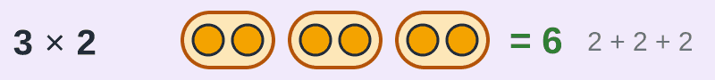

SAY
Ask: "What does 4 × 5 mean in words?" (4 groups of 5.) "How could you work it out if you forgot your tables?" (5 + 5 + 5 + 5 = 20.)

TOOL
The times table: keep it next to you all session
To find 6 × 7: put a finger on row 6 and slide along to column 7. You land on 42.
To divide, go backwards. For 42 ÷ 6, look along row 6 for 42. It sits under the 7, so 42 ÷ 6 = 7.
Nobody has to know the tables by heart. Keep this page open in your notes.
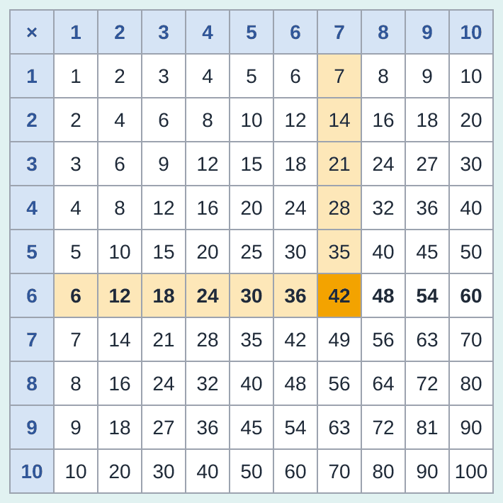

SAY
Do one together: "Find 8 × 4." (Row 8, column 4: 32.) And one backwards: "32 ÷ 8?" (Row 8, find 32, look up: 4.)

PICTURE IT
Dividing asks: how many groups fit?
12 ÷ 4 asks: how many groups of 4 fit into 12?
Make groups of 4: three groups fit exactly. So 12 ÷ 4 = 3.
Sometimes a few are left over. That is the remainder: 17 ÷ 5 = 3 remainder 2.
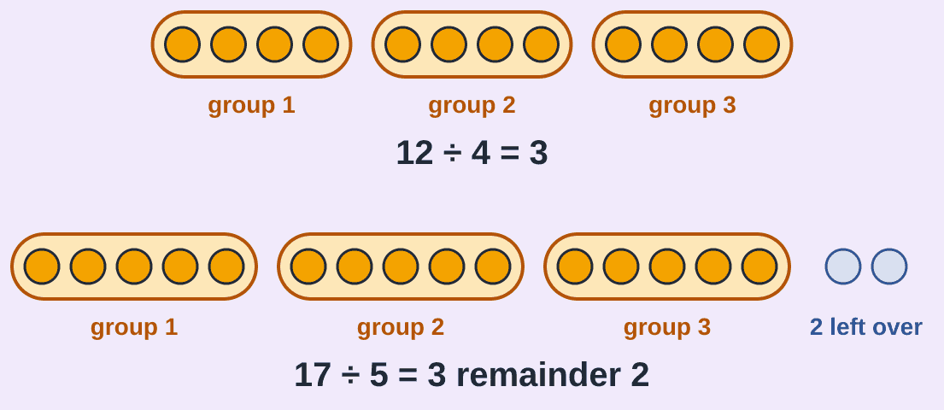

SAY
Dividing is also sharing: 12 sweets shared by 4 people gives 3 each. Same answer.

QUICK CHECK
Your go: 7 × 8, and 56 ÷ 7
Use the times table. Type the two answers.
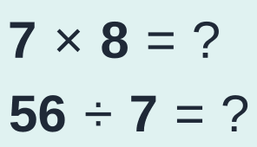
ANSWER
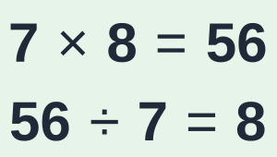
Row 7, column 8 gives 56. Backwards: find 56 in row 7. It sits under the 8.

Part 2 of 7: What a fraction is, and how to simplify it (slides 9–9)
The top counts the slices. The bottom says how many equal slices make one whole
PICTURE IT
A pizza is cut into 4 equal slices. You eat 1
The whole pizza was cut into 4 equal slices.
3 slices are left.
We write what is left as 3/4.
We say "three quarters", or "three out of four".
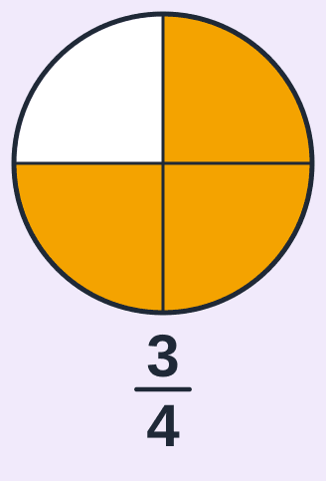

SAY
Before you click, ask: "How many slices was the pizza cut into? How many are left?"

WORDS TO KNOW
Each number in a fraction has its own job
The bottom number says how many equal slices make one whole. Here it is 4, so the slices are quarters.
The top number counts how many slices you have. Here it is 3.
The module guide calls the top the numerator and the bottom the denominator. (Denominator: Down.)
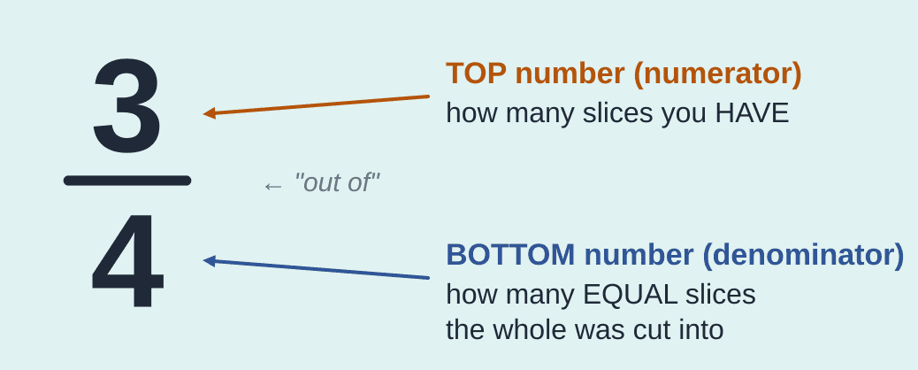

SAY
The bottom number NAMES the slices (quarters). The top number COUNTS them (three).

PICTURE IT
A bigger bottom number means SMALLER slices
Cut the same pizza into more slices, and each slice gets smaller.
So 1/8 is smaller than 1/4, even though 8 is bigger than 4.
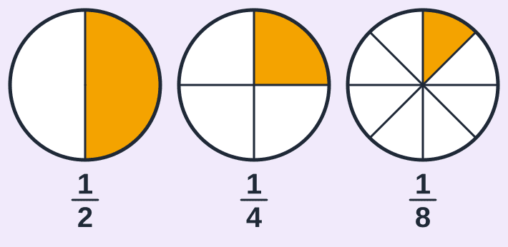

SAY
Ask: would you rather share a pizza with 2 people or with 8?

QUICK CHECK
Your go: what fraction is orange?
Count the slices. Type the fraction like this: top/bottom
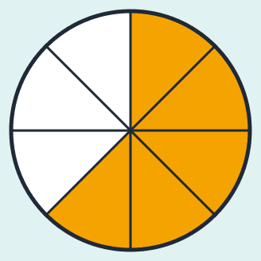
ANSWER

The pizza has 8 equal slices: that is the bottom. 5 of them are orange: that is the top.

PICTURE IT
Half a pizza is half a pizza, however you cut it
All three pizzas have the same amount coloured.
Only the number of cuts is different.
So 1/2, 2/4 and 4/8 are the same amount.
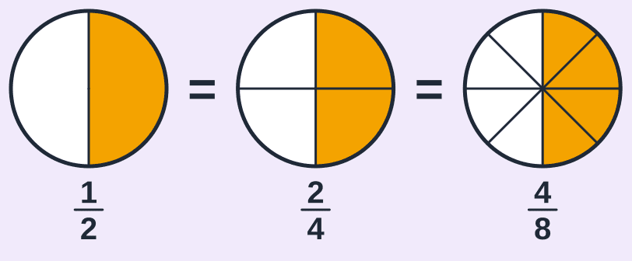

THE RULE
The golden rule of fractions
You may multiply the top and the bottom by the same number.
You may divide the top and the bottom by the same number.
The amount does not change. Only the numbers do.
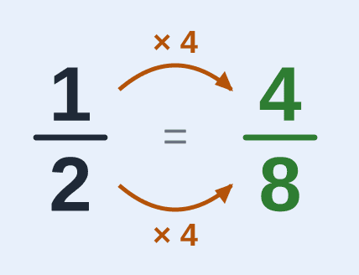

SAY
Have her say it back: "Whatever I do to the bottom, I do to the top."

WORDS TO KNOW
Simplifying: the same amount with smaller numbers
To simplify, divide the top and the bottom by a number that goes into both.
"Goes into" means it divides exactly, with nothing left over.
Keep going until 1 is the only number that goes into both. Then the fraction is finished.
The exam says "reduced to the lowest term". It means the same thing.
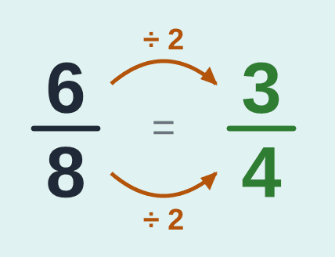

Quick tests: does it go in exactly?
Goes in? | The test | Example
2 | The last digit is even: 0, 2, 4, 6 or 8. | 36 ends in 6 ✓
3 | Add the digits. The total is in the 3 times table. | 45: 4 + 5 = 9 ✓
5 | The last digit is 0 or 5. | 45 and 60 ✓
10 | The last digit is 0. | 60 ✓

Worked example 1: simplify in small steps
Example 1
Simplify:
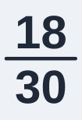
STEP  1 | Find a number that goes into BOTH 18 and 30. Both are even, so 2 goes into both. Divide the top and the bottom by 2.  Why? Half of 18 is 9. Half of 30 is 15.  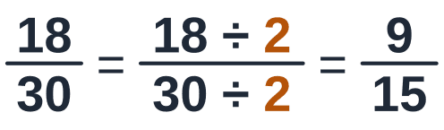
STEP  2 | Look again. 9 and 15 are both in the 3 times table. Divide the top and the bottom by 3.  Why? 9 ÷ 3 = 3 and 15 ÷ 3 = 5.  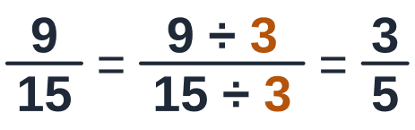
STEP  3 | Can 3/5 be simplified again? No: 1 is the only number that goes into both 3 and 5. Finished.  Why? Small steps are safe steps. You do not have to find the biggest number in one go.  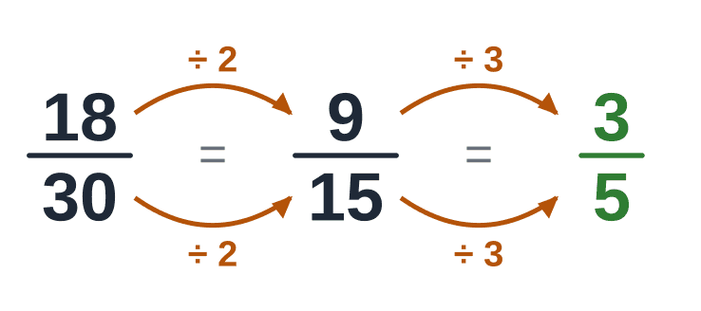  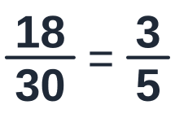
ANSWER

Check: Go back: 3 × 6 = 18 and 5 × 6 = 30 ✓

QUICK CHECK
Your go: simplify 10/15
Which number goes into both 10 and 15? Type the simplified fraction.
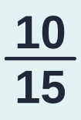
ANSWER
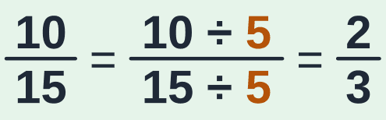
Both end in 0 or 5, so 5 goes into both: 10 ÷ 5 = 2 and 15 ÷ 5 = 3. Then 1 is the only number that goes into both 2 and 3.

Part 3 of 7: Improper fractions and mixed numbers (slides 25–25)
More slices than one whole holds
PICTURE IT
When the top is bigger than the bottom
7/4 has more slices than one pizza holds. A fraction like that is called an improper fraction.
Divide the top by the bottom: how many 4s fit into 7? One 4 fits, and 3 slices are left over.
So 7/4 is 1 whole pizza and 3 quarters: 1 3/4. That is a mixed number.
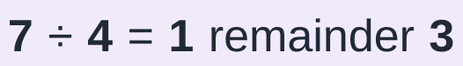
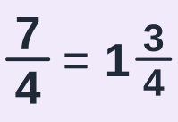
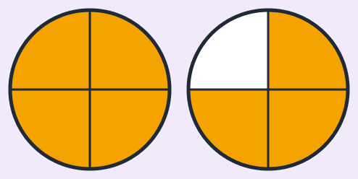

SAY
7 quarters: 4 of them make one whole pizza, and 3 quarters are left over.

Worked example 2: improper fraction → mixed number
Example 2
Write as a mixed number:
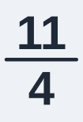
STEP  1 | Divide the top by the bottom: how many 4s fit into 11? Two 4s make 8. Three 4s make 12: too many. So 2 fit, and 11 − 8 = 3 are left over.  Why? Every 4 quarters make one whole.  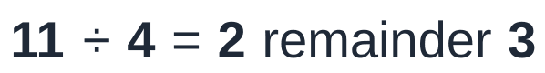
STEP  2 | The 2 is the whole number. The 3 left over is the new top. The slices are still quarters, so the bottom stays 4.  Why? The picture shows 2 whole pizzas and 3 quarters more.    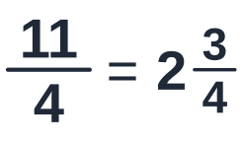
ANSWER
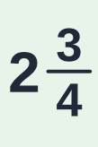
Check: Go back: 2 wholes are 8 quarters, plus 3 more makes 11 quarters ✓

TOOL
And back again: mixed number → improper fraction
Multiply the whole number by the bottom. That turns the wholes into slices.
Add the top. Those are the extra slices.
Write the total over the same bottom.
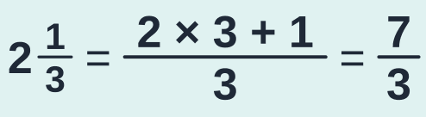
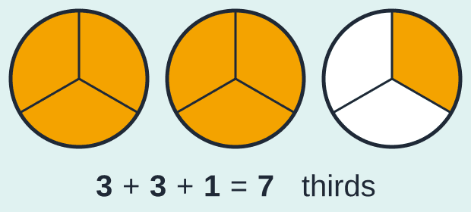

SAY
Each whole is 3 thirds. 2 wholes are 6 thirds, plus 1 more third makes 7 thirds.

QUICK CHECK
Fill in the blanks: 2 1/2 as an improper fraction
Type only the two missing numbers, in order.
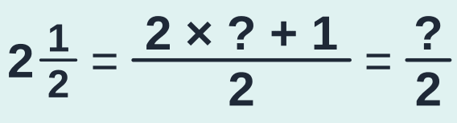
ANSWER
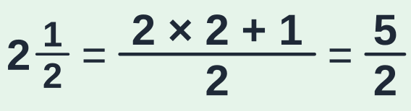
Whole number × bottom: 2 × 2 = 4 halves. Plus the 1 half on top: 5 halves.

Part 4 of 7: The sign × means "groups of": a whole number times a fraction (slides 33–33)
Multiply the top only
PICTURE IT
3 × 1/4 means 3 groups of a quarter
Take a quarter of a pizza, three times.
Count the slices: 1 quarter + 1 quarter + 1 quarter = 3 quarters.
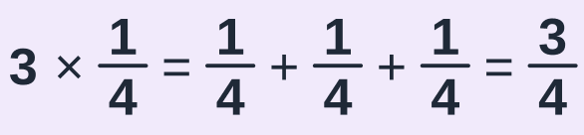
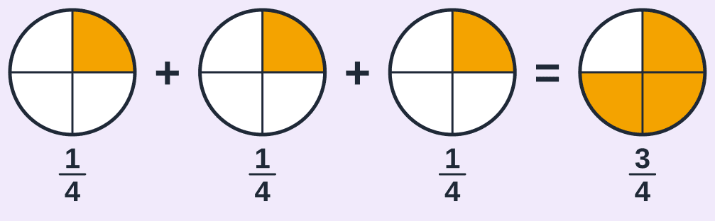

THE RULE
A whole number times a fraction: multiply the TOP only
The top counts the slices. 3 groups of 1 slice is 3 slices. So multiply the top by the whole number.
The bottom says which slices they are: quarters. They are still quarters. So the bottom stays the same.
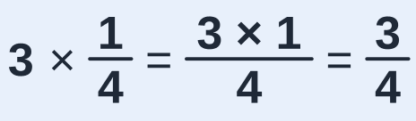

SAY
Have her say it back: "More groups means more slices, not bigger slices."

CAREFUL
Do NOT multiply the bottom as well
If you multiply the top AND the bottom by 3, you get 3/12.
3/12 simplifies back to 1/4. The amount has not changed at all. (That is the golden rule.)
Three groups of a quarter must be MORE than one quarter.
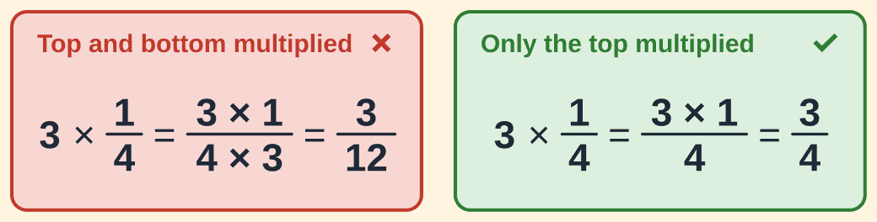

Worked example 3: 6 groups of two thirds (Lesson 3, Example 1)
Example 3 · Lesson 3, Worked example 1
Work out:
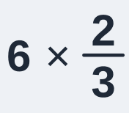
STEP  1 | Read the question out loud: "6 times two thirds". It means 6 groups of two thirds of a pizza.  Why? Saying it in words first tells you what to expect: many slices.  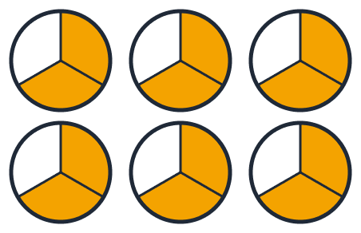
STEP  2 | Multiply the TOP by the whole number: 6 × 2 = 12. That is how many slices there are.  Why? Each group has 2 slices and there are 6 groups: 2 + 2 + 2 + 2 + 2 + 2 = 12.  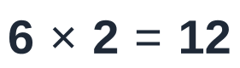
STEP  3 | The bottom stays 3, because every slice is still a third. Write 12 over 3.  Why? Multiplying changes HOW MANY slices you have. It does not change the size of the slices.  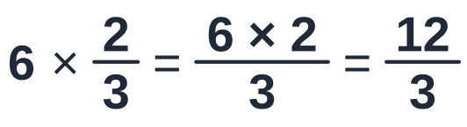
STEP  4 | The top (12) is bigger than the bottom (3), so there are whole pizzas inside. Divide the top by the bottom: how many 3s fit into 12? Four 3s make 12 exactly. Nothing is left over.  Why? Every 3 thirds make one whole pizza. 12 thirds make 4 whole pizzas.  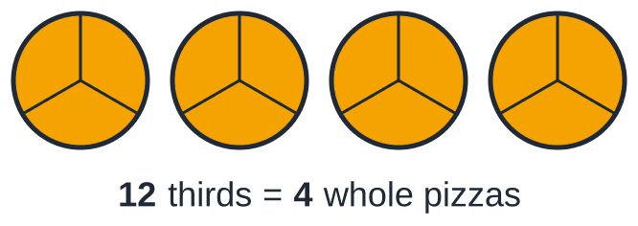  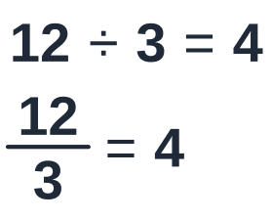
ANSWER

Check: Two thirds is a little more than half a pizza. Six halves would be 3 pizzas. So the answer should be a little more than 3 ✓

QUICK CHECK
Fill in the blanks: 4 × 2/5
Type only the three missing numbers, in order.
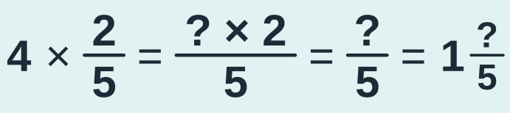
ANSWER
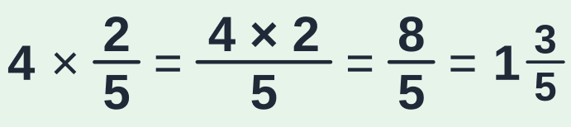
Multiply the top by the whole number: 4 × 2 = 8. The bottom stays 5. Then 8 ÷ 5 = 1 remainder 3: one whole and 3 fifths.

Part 5 of 7: A fraction OF something: "of" means × (slides 45–45)
Fraction × fraction: top × top, bottom × bottom, then simplify
PICTURE IT
What if the number in front is a fraction? Half a group
2 × 6 is two groups of 6. That is 12.
1 × 6 is one group of 6. That is 6.
1/2 × 6 is half a group of 6. That is 3.
So 1/2 × 6 means "half OF 6". In maths, the word "of" means ×.
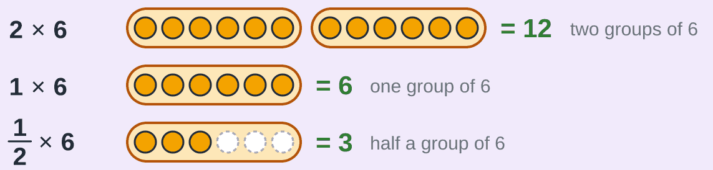

PICTURE IT
Half OF three quarters of a slab of chocolate
The slab has 4 columns. 3/4 of it is yours: the 3 coloured columns.
You give away half OF your part. Cut across the middle and take the top row: the orange part.
The whole slab is now in 8 small pieces. The orange part is 3 of those 8.
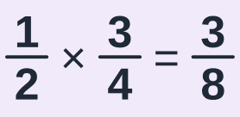
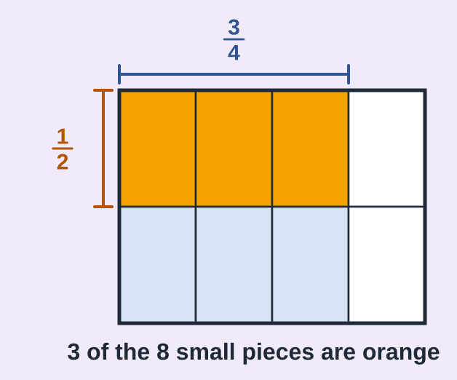

SAY
Ask: "How many small pieces is the whole slab cut into now?" (8.) "How many are orange?" (3.)

WHY IT WORKS
Where do the 3 and the 8 come from?
The 8 on the bottom: 2 rows × 4 columns = 8 small pieces in the whole slab. That is bottom × bottom.
The 3 on top: 1 row × 3 columns = 3 orange pieces. That is top × top.
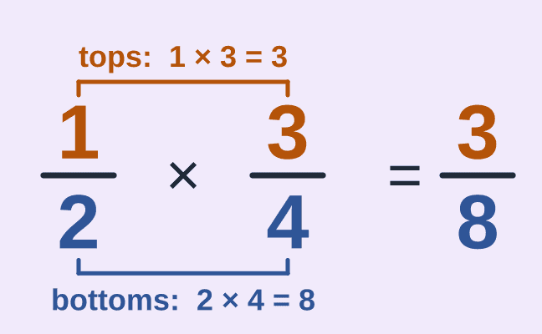

THE RULE
To multiply fractions: top × top, bottom × bottom, then simplify
1. Multiply the tops. That is the new top.
2. Multiply the bottoms. That is the new bottom.
3. Simplify the answer if you can.
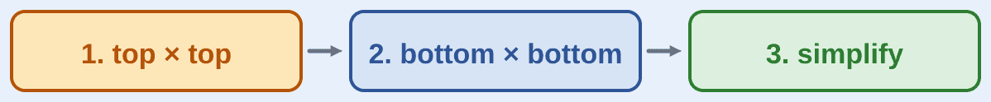

SAY
The same three moves every time: "Tops. Bottoms. Simplify."

Worked example 4: two thirds of five sixths (Lesson 3, Example 2)
Example 4 · Lesson 3, Worked example 2 (module guide Example 1.6, page 27)
Work out:
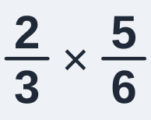
STEP  1 | Read the question: "two thirds TIMES five sixths". That means two thirds OF five sixths. In the slab picture: 5 of the 6 columns, then 2 of the 3 rows.  Why? The orange part is the answer. It must be smaller than five sixths, because we only take part of it.  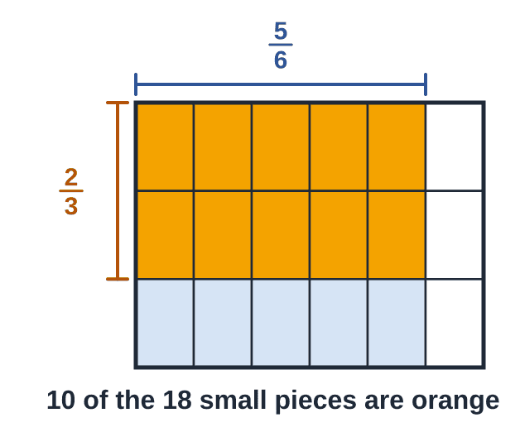
STEP  2 | Tops first: 2 × 5 = 10. Write 10 on top of the answer.  Why? In the slab picture: 2 rows × 5 columns = 10 orange pieces.  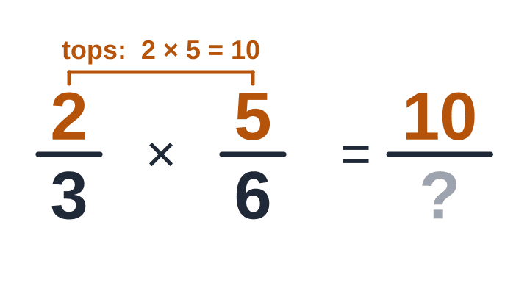  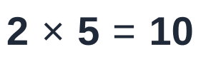
STEP  3 | Now the bottoms: 3 × 6 = 18. Write 18 underneath.  Why? In the slab picture: 3 rows × 6 columns = 18 small pieces in the whole slab.  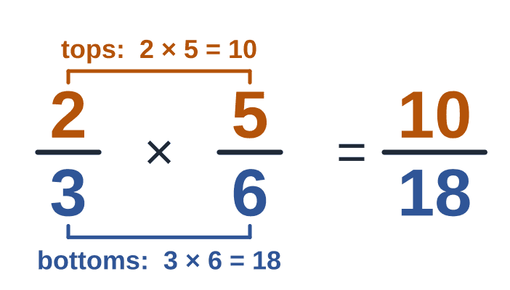  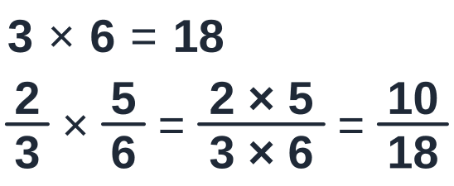
STEP  4 | Last, simplify 10/18. Both are even, so 2 goes into both. Divide the top and the bottom by 2.  Why? Half of 10 is 5. Half of 18 is 9. Then 1 is the only number that goes into both 5 and 9, so it is finished.  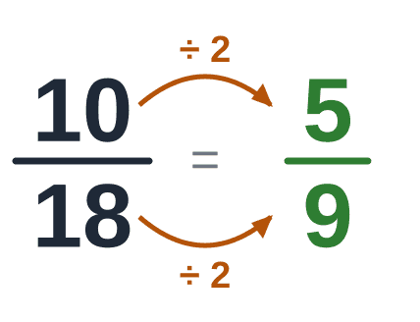  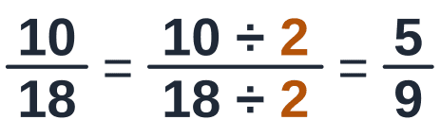
ANSWER

Check: Count the slab picture: 10 of the 18 small pieces are orange, and 10/18 simplifies to 5/9 ✓

QUICK CHECK
Your go: 1/2 × 1/3
Half OF a third. Top × top, bottom × bottom.
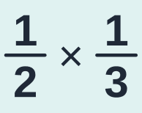
ANSWER
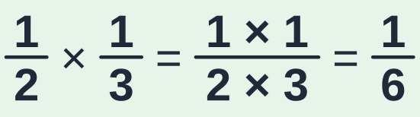
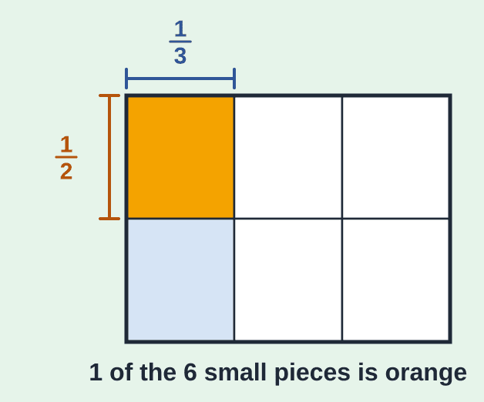
Tops: 1 × 1 = 1. Bottoms: 2 × 3 = 6. Half of a third is a sixth. Nothing to simplify.

Part 6 of 7: A whole number or a mixed number in a multiplication (slides 58–58)
Turn everything into a plain fraction first
THE RULE
First turn every number into a plain fraction
A plain fraction is just a top and a bottom, with no whole number in front.
A whole number: write it over 1. 3 = 3/1, because 3 ÷ 1 is still 3.
A mixed number: change it into an improper fraction (Part 3).
Then multiply as before: top × top, bottom × bottom.
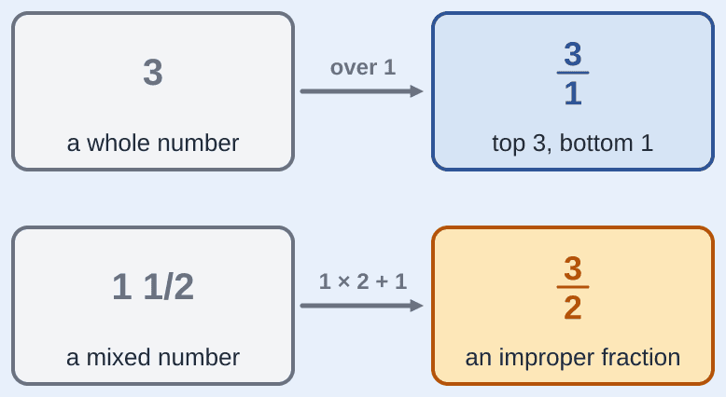

Worked example 5: three groups of one and a half
Example 5 · Lesson 3, "Your go" at the end of Idea 3
Work out:
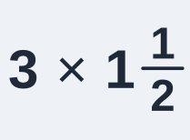
STEP  1 | Make both numbers plain fractions. 3 is 3/1. And 1 1/2 is 3/2, because 1 × 2 + 1 = 3.  Why? One whole is 2 halves, plus 1 more half makes 3 halves.  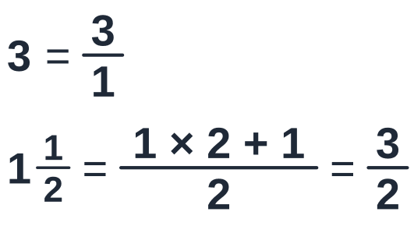
STEP  2 | Tops: 3 × 3 = 9. Bottoms: 1 × 2 = 2.  Why? Top × top, bottom × bottom.  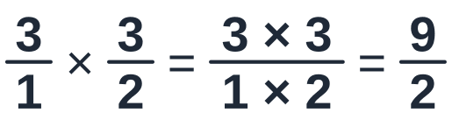
STEP  3 | The top is bigger than the bottom. Divide: how many 2s fit into 9? Four 2s make 8, and 1 is left over.  Why? Every 2 halves make one whole.  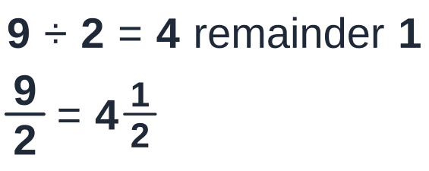
ANSWER
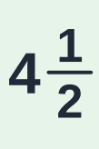
Check: In money: 3 groups of R1.50 is R4.50 ✓

Part 7 of 7: A fraction OF an amount (slides 64–64)
Divide by the bottom, then multiply by the top
PICTURE IT
What is 2/5 of R100?
"2/5 OF R100" means: share the R100 into 5 equal parts, then take 2 of the parts.
One part: R100 ÷ 5 = R20. (Five R20 notes make R100.)
Two parts: 2 × R20 = R40.
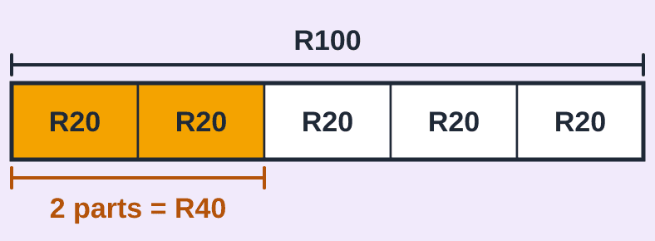

SAY
Before you show this slide, ask: "If five people share R100 equally, how much does each get?" Then: "And two of them together?"

THE RULE
Divide by the bottom, then multiply by the top
÷ bottom gives the size of ONE part. (The bottom says how many equal parts there are.)
× top takes as many parts as you need. (The top says how many parts you want.)
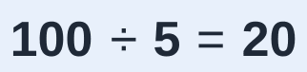
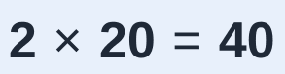

SAY
Two small calculations, always in this order: divide by the bottom, multiply by the top.

TOOL
Dividing a number that ends in 0
For 120 ÷ 4, leave the 0 off: 12 ÷ 4 = 3. Then put the 0 back: 30.
Why? 120 is 12 tens. 12 tens shared by 4 is 3 tens, which is 30.
Check by multiplying back: 4 × 30 = 120 ✓

Worked example 6: the staff canteen (Lesson 3, Example 5)
Example 6 · Lesson 3, Worked example 5
A company has 120 staff. 3/4 of them use the canteen. How many staff use the canteen?
STEP  1 | Find the fraction and the amount. The fraction is 3/4. The amount is 120 staff. "3/4 OF 120" means: split the staff into 4 equal groups and take 3 of the groups.  Why? The bottom (4) says how many equal groups. The top (3) says how many groups we want.  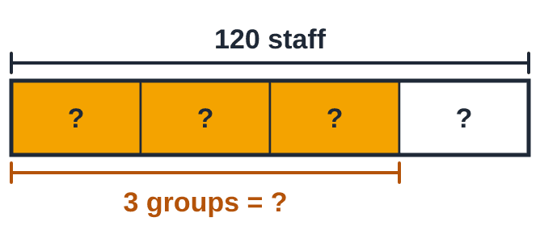
STEP  2 | Divide by the bottom to find ONE group: 120 ÷ 4. Think of 12 ÷ 4 = 3, so 120 ÷ 4 = 30.  Why? 120 is 12 tens. 12 tens shared by 4 is 3 tens, which is 30. Check: 30 + 30 + 30 + 30 = 120.  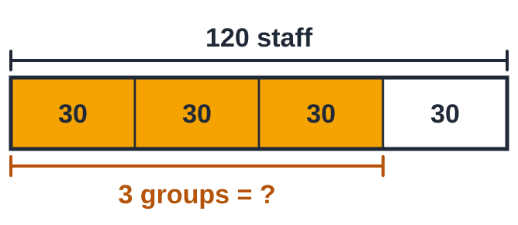  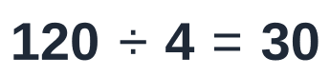
STEP  3 | Multiply by the top to get THREE groups: 3 × 30 = 90.  Why? 3 groups of 30: 30 + 30 + 30 = 90.  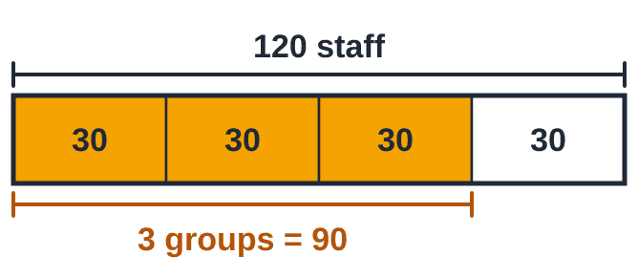  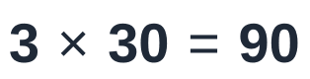
STEP  4 | Check: the one group left over (30 people) does not use the canteen. The two numbers together must be everyone.  Why? The people who use it plus the people who do not must add up to all 120 staff.  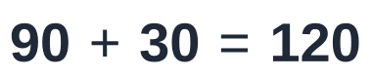
ANSWER
90 staff use the canteen.

LOOK
You have caught up with the group
The group stopped at the end of this example.
Next session you continue together from Lesson 3, Worked example 6 ("the part that is left").
After that comes Idea 5 of Lesson 3: dividing fractions.

SAY
Tell her where to find Worked example 6 in her Lesson 3 notes, in case she wants to look ahead.

Exit ticket (slides 74–80)
Last 5 minutes. They work alone and send you their working privately (a photo is fine). It is your early-warning system: if more than half the group miss a question, open the next lesson by re-teaching it.
Exit ticket 1
Simplify:
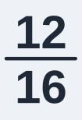
STEP  1 | Both are even: divide the top and the bottom by 2.  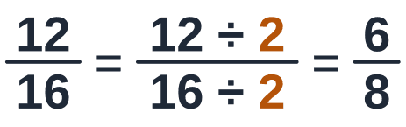
STEP  2 | Both are still even: divide by 2 again. Then 1 is the only number that goes into both 3 and 4.  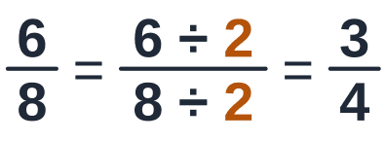
ANSWER


Exit ticket 2
Work out:
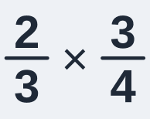
STEP  1 | Top × top, bottom × bottom.  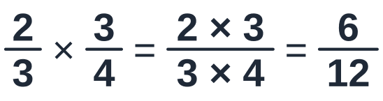
STEP  2 | Simplify: 6 goes into both 6 and 12.  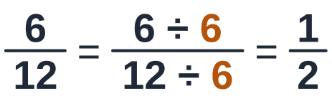
ANSWER


Exit ticket 3
Find 3/5 of R200.
STEP  1 | Divide by the bottom: 200 ÷ 5. Leave a 0 off: 20 ÷ 5 = 4. Put the 0 back: 40.  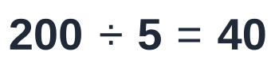
STEP  2 | Multiply by the top.  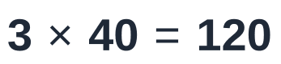
ANSWER
R120

Homework (slides 81–82)
The students have the full working under each question in their notes, so homework is about practising and self-checking, not about marks. The next deck opens with a homework check.
Homework 1
Simplify:
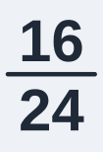
STEP  1 | Both are even: divide the top and the bottom by 2.  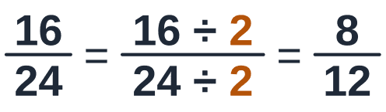
STEP  2 | Both are still even: divide by 2 again.  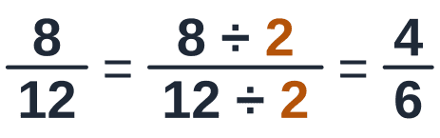
STEP  3 | Still even: divide by 2 once more. Then 1 is the only number that goes into both 2 and 3. Finished.  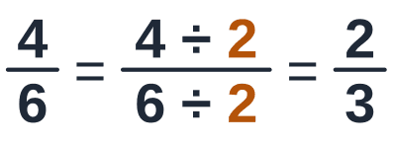
ANSWER

Check: Go back: 2 × 8 = 16 and 3 × 8 = 24 ✓

Homework 2
Write as a mixed number:
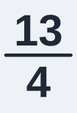
STEP  1 | How many 4s fit into 13? Three 4s make 12. Four 4s make 16: too many. So 3 fit, and 13 − 12 = 1 is left over.  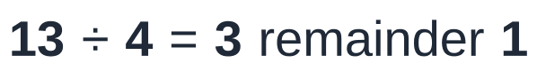
STEP  2 | The 3 is the whole number. The 1 left over is the new top. The bottom stays 4.  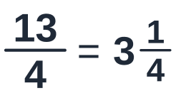
ANSWER
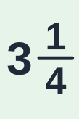

Homework 3
Work out:
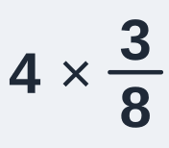
STEP  1 | A whole number times a fraction: multiply the top only. 4 × 3 = 12. The bottom stays 8.  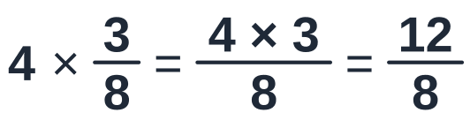
STEP  2 | Simplify: 12 and 8 are both in the 4 times table. Divide both by 4.  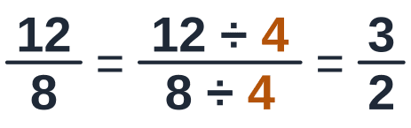
STEP  3 | The top is bigger than the bottom: 3 ÷ 2 = 1 remainder 1.  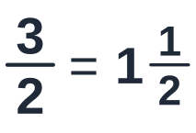
ANSWER
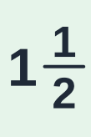

Homework 4
Work out:
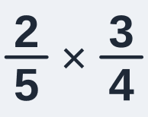
STEP  1 | Top × top, bottom × bottom.  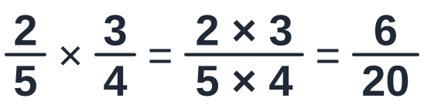
STEP  2 | Simplify: both are even, so divide both by 2. Then 1 is the only number that goes into both 3 and 10.  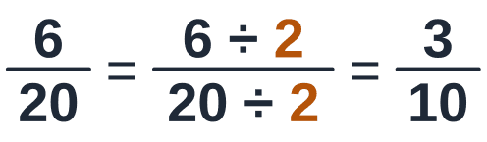
ANSWER
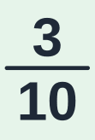

Homework 5
A shop takes R240 in a morning. 3/8 of it is for cold drinks. How much is that?
STEP  1 | Divide by the bottom to find ONE part: 240 ÷ 8. Leave the 0 off: 24 ÷ 8 = 3. Put the 0 back: 30.  Why? Row 8 of the times table: 8 × 3 = 24.  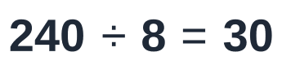
STEP  2 | Multiply by the top to get THREE parts.
ANSWER
R90 is for cold drinks.
Check: Rough check: 3/8 is a little less than half. Half of R240 is R120, and R90 is a little less ✓

Homework 6: reading list
Read these parts of your notes, in this order, before the BODMAS lesson. Try each question before you look at its working.
STEP  1 | Lesson 2 notes, Ideas 4 to 6: adding and subtracting fractions. Lesson 3 uses them again in its homework, and the BODMAS lesson needs them. In Idea 5, find the LCD by listing multiples. You can skip the prime ladder: the group does not use it any more.
STEP  2 | Lesson 1 in the Student Workbook, Ideas 1 and 2: place value, rounding and negative numbers. The decimals lesson needs the rounding. The BODMAS lesson needs the negative numbers.
STEP  3 | Stuck on something? Put a star next to it and bring it to the next session.
ANSWER
No answer to check: the notes have every question worked in full.

Today in a few lines (slides 83–83)
- × means "groups of". ÷ asks "how many groups fit?" The times table does both.
- A fraction: the bottom says how many equal slices make one whole. The top counts the slices you have.
- Simplify: divide the top and the bottom by a number that goes into both, until only 1 goes into both.
- Improper → mixed: divide the top by the bottom. Mixed → improper: whole number × bottom, plus the top.
- Whole number × fraction: multiply the top only. Fraction × fraction: top × top, bottom × bottom, then simplify.
- A fraction OF an amount: divide by the bottom, then multiply by the top.
Next lesson: With the group: Lesson 3 from Worked example 6 ("the part that is left"), then dividing fractions.

